UMKC

Network Architecture – 1

Dwarkamoye Mohanty

16281824

Assignment -2

1.(a) **Nonpersistent HTTP** (Without parallel connection)

2 RTT are required one for TCP other for base html request-response

Total = 2RTT + Transmit

For 9 objects:

For each object 2RTT are required one for TCP connection and one for object

request-response

Transmit = 9*2RTT = 18RTT

**Total = 2RTT + 18RTT = 20RTT**

1. **Persistent HTTP**

Without pipe-lining:

2 RTT are required one for TCP other for base html request-response

For 9 objects:

For each object 1RTT are required

**Total = 2RTT+9RTT = 11RTT**

With pipe-lining:

2 RTT are required one for TCP other for base html request-response

For 9 objects:

1RTT is required for al objects

**Total = 2RTT+1RTT = 3RTT**

**2.(i)**

Choosing the TLD server depends on the domain name extension.

Choose the domain name extension:

Below are few examples of TLD servers.

* .com (Top level Domain)
* .org (Organizational)
* .edu (Educational Institutions)

Here assuming startup company’s name is ‘nwguru.com’. We need to register our domain to .com TLD server.

Choose the registrar:

There are multiple registrars available in the market such as GoDaddy, Register.com, NameCheap, name.com, GoSpace. All these companies are authorized by ICANN (Internet Corporation for Assigned Names and Numbers) to sell the domain names. Have some basic idea about prices and services offered such as Web Hosting, since it varies by registrar.

Domain name: nwguru.com

Static IP: XX:XX:XX:XX

DNS : dns1.nwguru.com

Mail server : mx.nwguru.com

Then the registrar registers the following Resource Records into

“.com” TLD server :-

Web server: (nwguru.com, dns1.nwguru.com, NS)

(dns1.nwguru.com, XX:XX:XX:XX,A)

Authoritative name server :-

Mail server: (nwguru.com, mx.nwguru.com, MX)

(mx.nwguru.com, XX:XX:XX:XX,A)

**ii)**

There are multiple registrars available in the market such as GoDaddy, Register.com, NameCheap, name.com, GoSpace. Brand new domains will cost about $10-15 a year , depending on registrar and TLD.

The major factors responsible different fee structures:

* Extension name that we choose such as .com, .edu
* The length of the registration, which is by default in between 0-10 years.

Below are some details as per company:

|  |  |  |
| --- | --- | --- |
| **Company** | **Price (lowest) in $ per year** | **Price(.com) in $ per year** |
| HostPapa | 0.95 | 12.95 |
| NameCheap | 0.99 | 10.98 |
| GoDaddy | 0.99 | 14.99 |

Here is the sample example of domain prices:

|  |  |  |
| --- | --- | --- |
| **Domain Extension** | **Price in $** | **Duration in yr** |
| .com | 11.99 | 1 |
| .net | 12.69 | 1 |
| .biz | 9.99 | 1 |
| .org | 8.99 | 1 |

**LABORATORY ASSIGNMENT**

**Part 1: Telnet experiments**

**HTTP request (GET)**

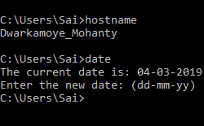



Type GET /index.html

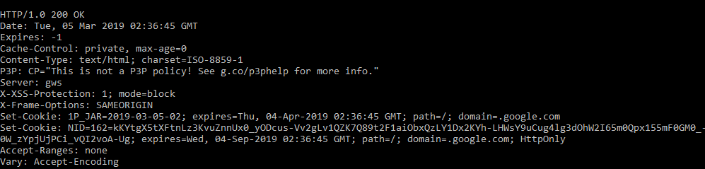

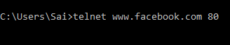

Type GET /

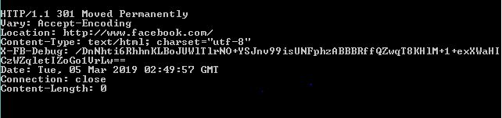

**HTTP HEAD**



Type HEAD /

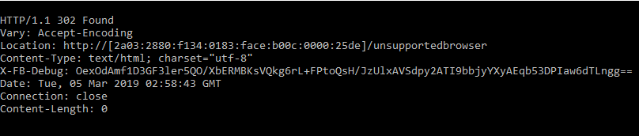

**HTTP POST**



Type POST /

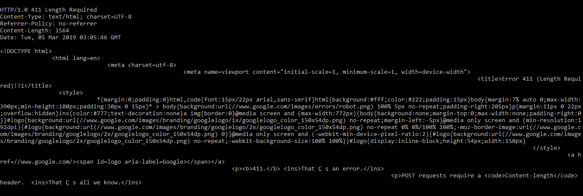

**Part 2 - Wireshark experiments**

**The Basic HTTP GET/response interaction**

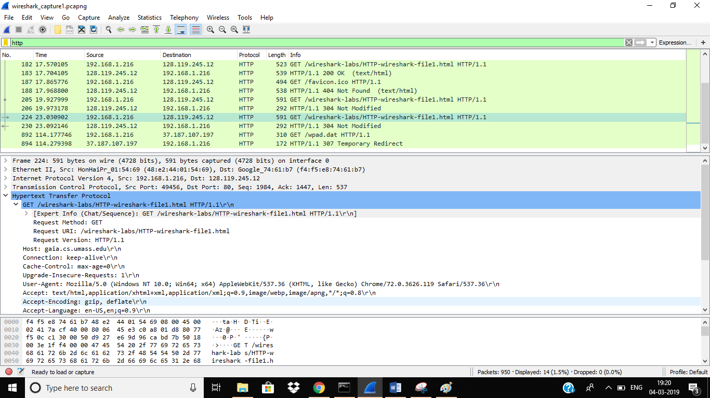

**1. Is your browser running HTTP version 1.0 or 1.1? What version of HTTP is the server running?**

The HTTP version is **1.1 both sides.**

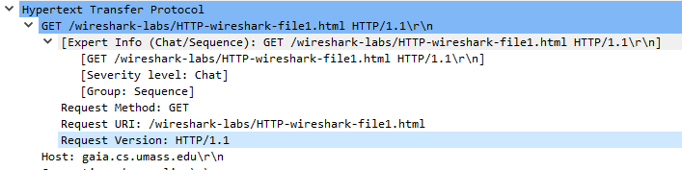

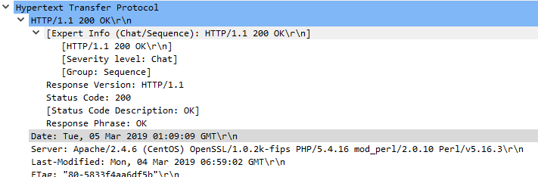

**2.What languages (if any) does your browser indicate that it can accept to the server?**

The Browser accepts **English** language.

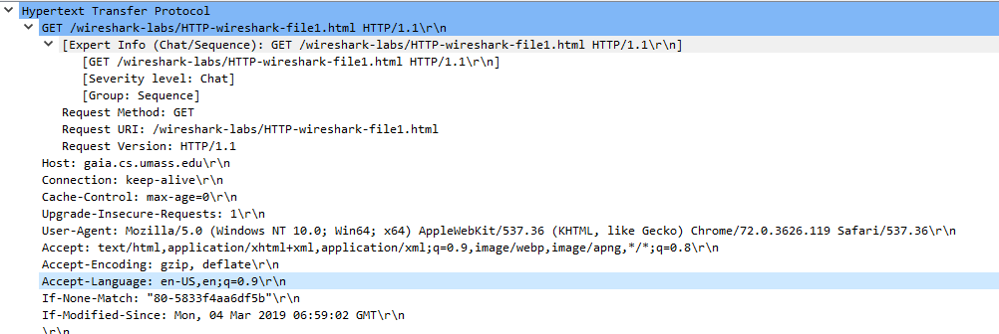

**3. What is the IP address of your computer? Of the gaia.cs.umass.edu server?**

IP address of my computer – **192.168.1.216**

IP address of gaia.cs.umass.edu – **128.119.245.12**

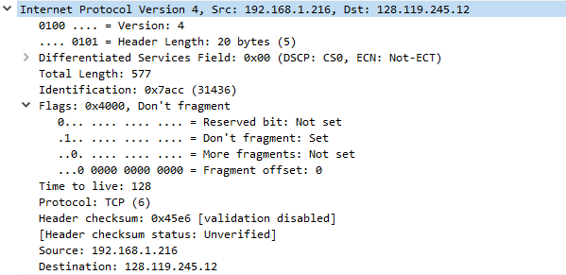

**4. What is the status code returned from the server to your browser?**

The status code returned is **200 OK** from server to browser.

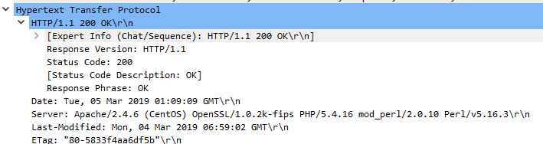

**5. When was the HTML file that you are retrieving last modified at the server?**

The HTML file was last modified at server at **Mon, 04 Mar 2019 06:59:02 GMT**

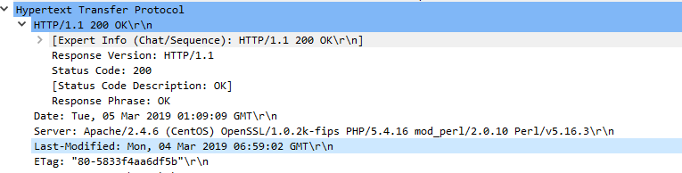

**6. How many bytes of content are being returned to your browser?**

Content returned to browser is **128 bytes**

